**Project Design Phase-II**

**Technology Stack (Architecture & Stack)**

|  |  |
| --- | --- |
| Date | 27 June 2025 |
| Team ID | LTVIP2025TMID32415 |
| Project Name | Poultry Disease Classification for Health Management |
| Maximum Marks | 4 Marks |

**Technical Architecture:**

The Deliverable shall include the architectural diagram as below and the information as per the table1 & table 2

**Example: Order processing during pandemics for offline mode**



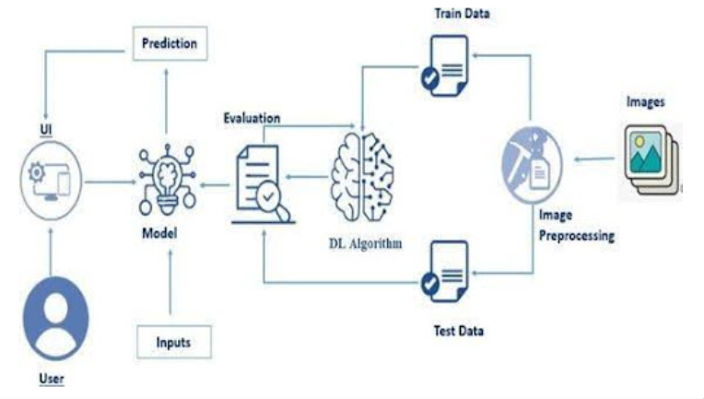

## Architecture Overview:

**The architecture consists of three main components:**

1. **Frontend (User Interface)**
2. **Backend (API + Model Inference)**
3. **Database & Storage**Technology Stack:

|  |  |
| --- | --- |
| **Component** | **Technology / Tool** |
| **Frontend** | **HTML, CSS, JavaScript, Bootstrap/Tailwind (for UI)** |
|  | **React.js (optional for better interactivity)** |
| **Backend** | **Python (Flask or Django for REST APIs)** |
|  | **TensorFlow / Keras (for Transfer Learning Model)** |
|  | **OpenCV (for image preprocessing** |
| **Database** | **SQLite / MySQL (for storing user data, history, reports)** |
|  | **Firebase (optional for authentication)** |
| **Storage** | **Local storage / Cloud (AWS S3, Google Cloud Storage for images)** |
| **Authentication** | **Email/OTP-based verification with SMTP** |
| **Deployment** | **Render / Vercel / Heroku / AWS (for hosting web app)** |
| **Monitoring** | **CloudWatch Logs (optional)** |

## Solution Architecture Diagram (Description):

* **Users access the web interface via browsers.**
* **They upload poultry images through the frontend.**
* **Backend API receives the image and processes it using a Transfer Learning Model (ResNet, VGG, etc.).**
* **The model predicts whether the bird is healthy or identifies the disease.**
* **The backend returns the result, including the disease name, confidence score, and possible remedies.**
* **User data, prediction history, and reports are stored in a relational database (SQLite/MySQL).**
* **Authentication handled via OTP or Email.**
* **The entire system is hosted on a cloud platform like Render or AWS.**